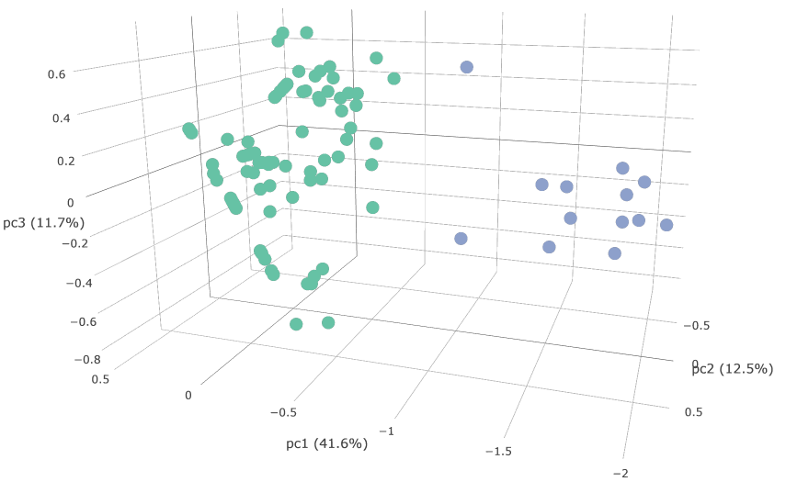

Figure 1. **Principal components visualization of pollen-specific promoter elements.** PCA plot shows the separation between pollen-specific HRGP genes non-pollen HRGP genes.